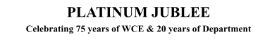

# Walchand College of Engineering, Sangli

***(Government Aided Autonomous Institute)***

Department of Information Technology

Computer Networks Lab

EVEN SEMESTER AY 2021-22

*Submitted by*

Name: Om Vivek Gharge

PRN: 2020BTEIT00041

Batch: S2

Course Code: 5IT272 Date: 14/06/2022

Contact Number: 9730369761

**Department of Information Technology**

2021-22

### Experiment Number: 11

**Experiment Name:** Using wireshark capture the packets to identify the password with HTTP and HTTPS request.

# Contents:

**Problem Statement :** Using wireshark capture the packets to identify the password with HTTP and HTTPS request.

**Platform :** Wireshark

**Site:** WCE Moodle

**Steps:**

1. Start capturing packets in Wireshark
2. Login in by entering username and password from login page
3. Stop capturing packets
4. Search the packets by command “tcp contains user” to search packet containing username and password.
5. Get the username and password from the packet

**Screenshots:**

Login Page:

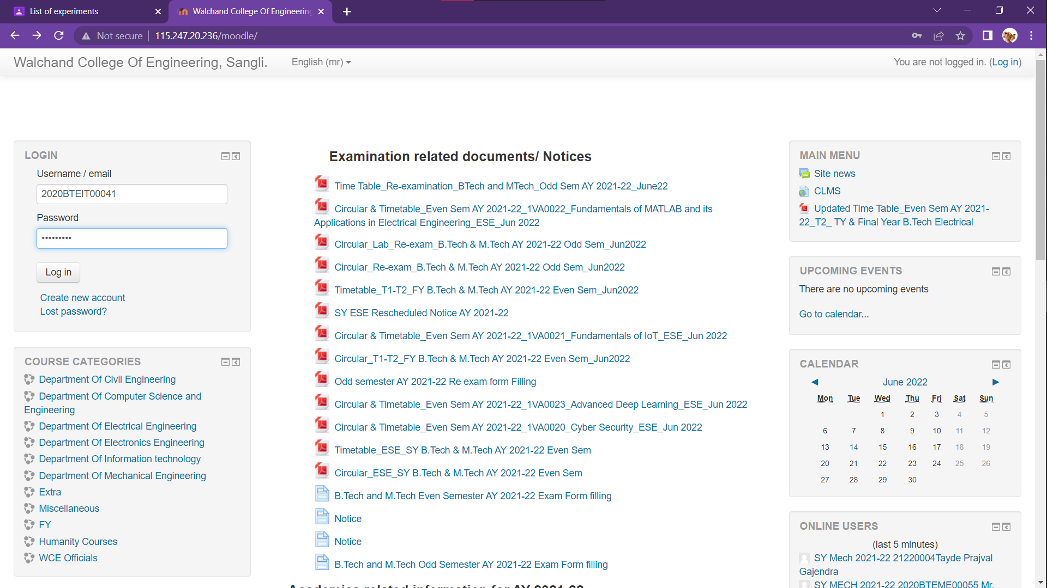

**Captured Packets:**

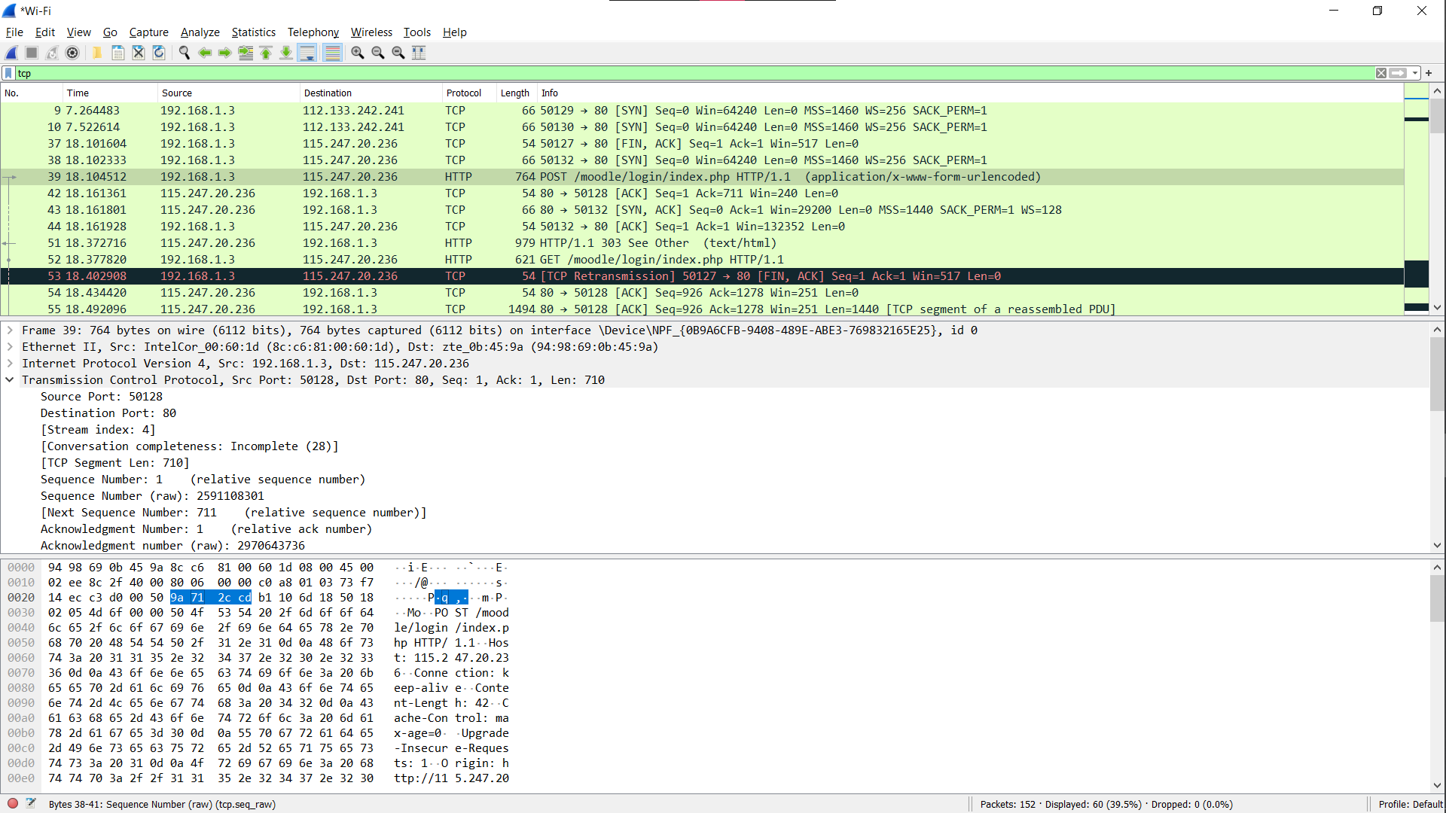

**Using command “tcp contains user” we can shortlist the packet with the username and password:**

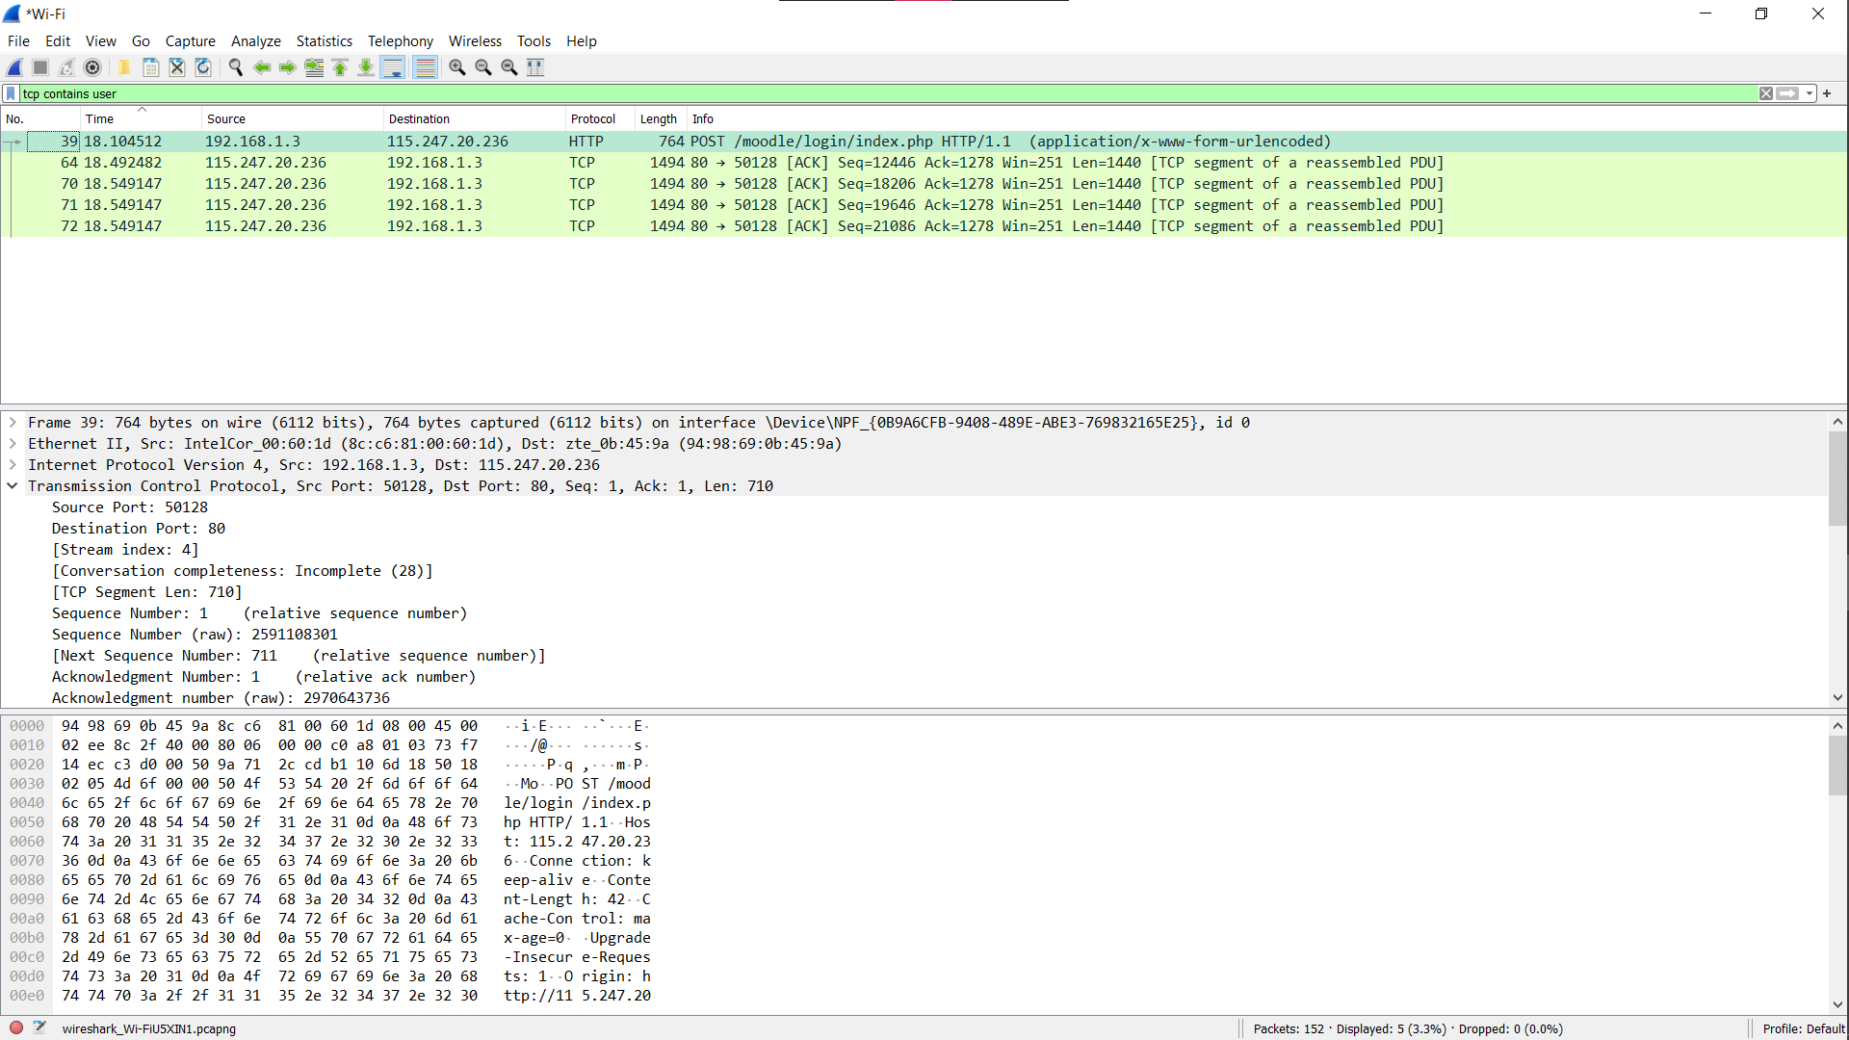

**Searching the packet for username and password:**

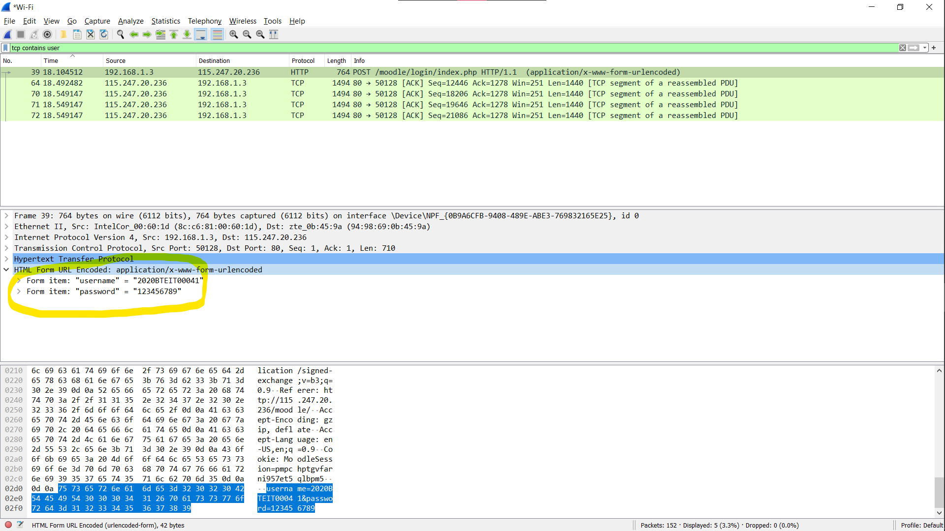

**The username and password are captured.**

**Conclusion:**

As seen in the above images, Live packets from LAN and Username and Password are captured using Wireshark.